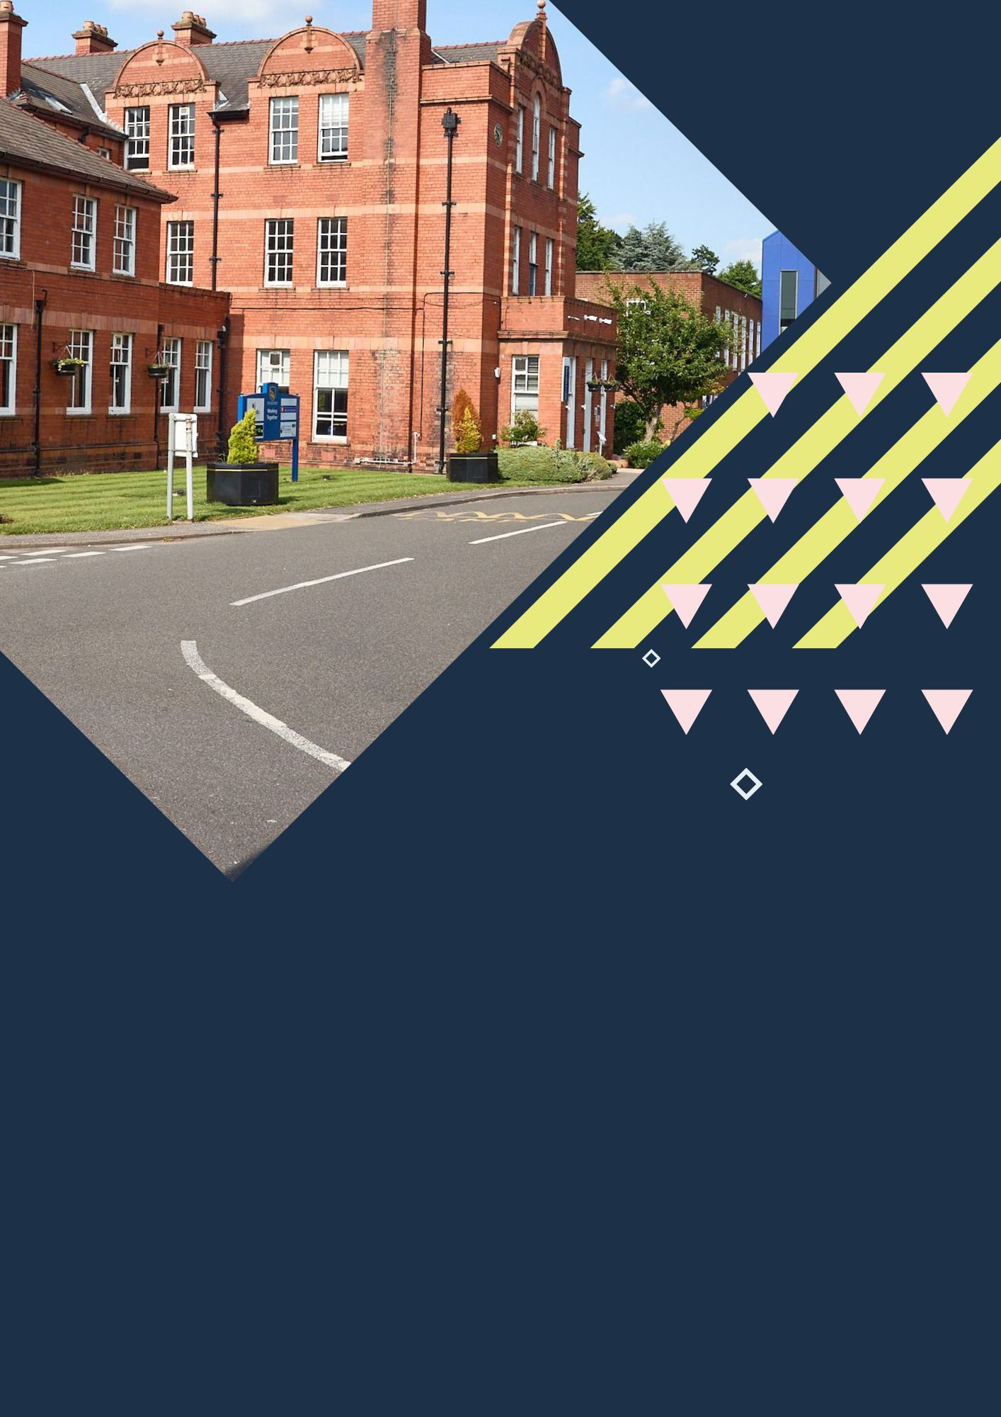



Crewe, Cheshire College Campus
Centre Handbook
2026

Contents

Contents 2
The Centre 3
Location 4
Airport Transfers: 4
Local Amenities 6
Accommodation 8
Room Allocation 8
Housekeeping 8
Key Loss 8
Deposits 8
Meals 8
Meal times 8
Technology 10
Security 10
Safety 10
Teaching 11
Programme 12
A typical day for students 13
Evening entertainment 15

Thank you very much for your interest in our centre in Crewe. We hope you find everything you need in the following pages but if you have any questions or specific requests then please get in touch with us at Head Office on 0044 1244 577995.
The contents of this handbook are updated regularly. The latest version will be sent before your arrival.
We look forward to a successful 2026 at our Crewe Cheshire Campus!

The Centre

Since 1912 when the Cheshire Crewe Campus first opened its doors as a College, it has been a centre of education with a history of major educational establishments and it is proud to continue this heritage.

It is a closed site with high security. CCTV on campus, the house buildings have coded doors or use of a key for access, an entrance gate which is manned with an on-site security guard.

On campus there are sports facilities and grass areas where students can take part in sports and activities.

In this centre, we accept students travelling as part of a group from *11- 17 years old.

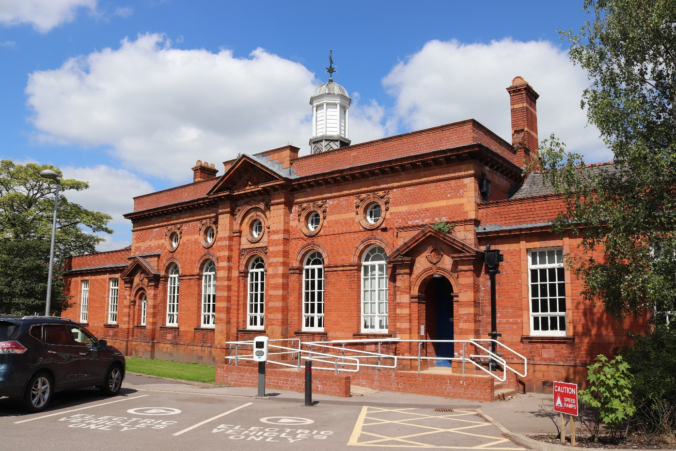

Location

Crewe Campus - Apollo Buckingham Health Sciences Campus Ltd
Couzens Building, Crewe Green Rd, Crewe CW1 5DU
Telephone Number: 01270 353200

Population of Cheshire - 1,108,765

The Cheshire Campus is located approximately – 1.4 miles from the town centre of Crewe

Cheshire county is famous for the production of Cheshire cheese, salt and silk. The county has seen a number of inventions and firsts in its history. A mainly rural county, Cheshire has a high concentration of villages. Cheshire is home to many historic structures, including the Chester Roman Amphitheatre, Britain's largest stone-built Roman amphitheatre. The city of Chester is also home to the Chester City Walls, a 2-mile route around the city that offers a unique vantage point from which to view Chester and the surrounding area

Crewe is widely known for its historic railway connection. In the 19th century, the town was home to one of the world’s most renowned railway workshops, which played a key role in engineering and design innovation, creating locomotives that contributed to the town’s prosperity and prestige.

Airport Transfers:

Manchester airport; 35 Minutes
Liverpool John Lennon: 50 Minutes
Birmingham airport: 1 hour 20 Minutes
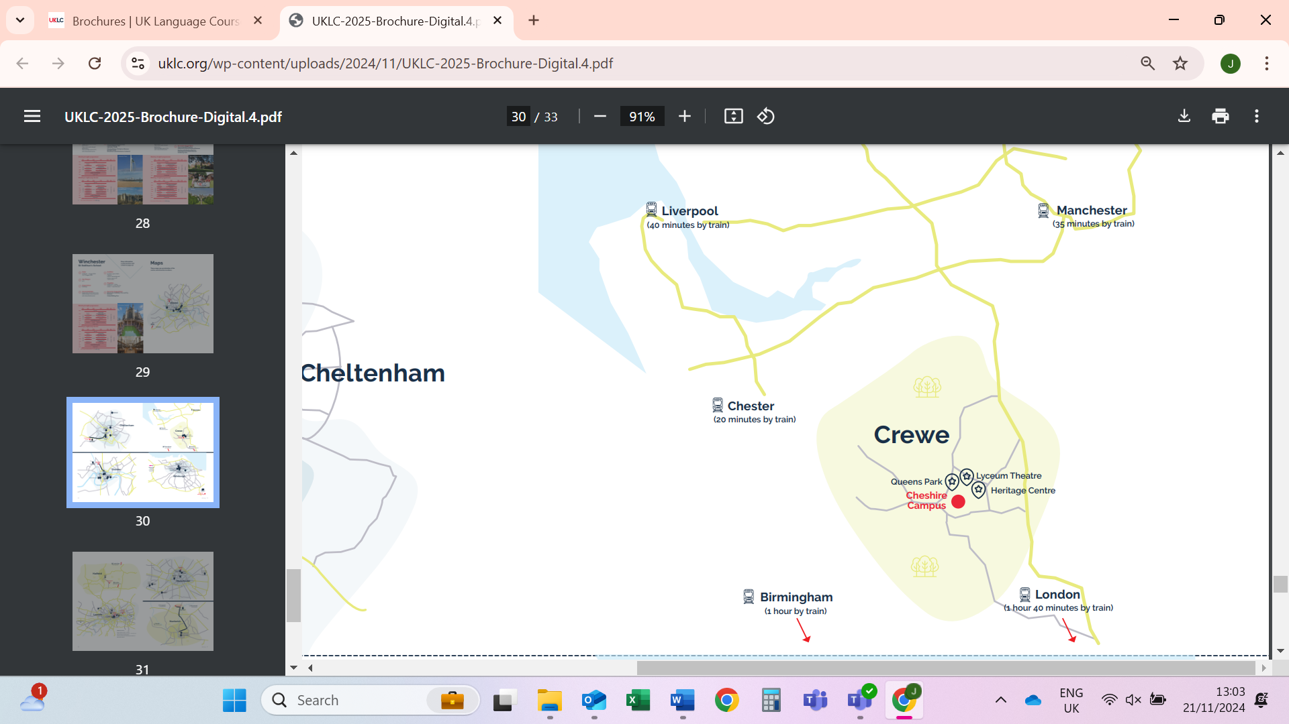
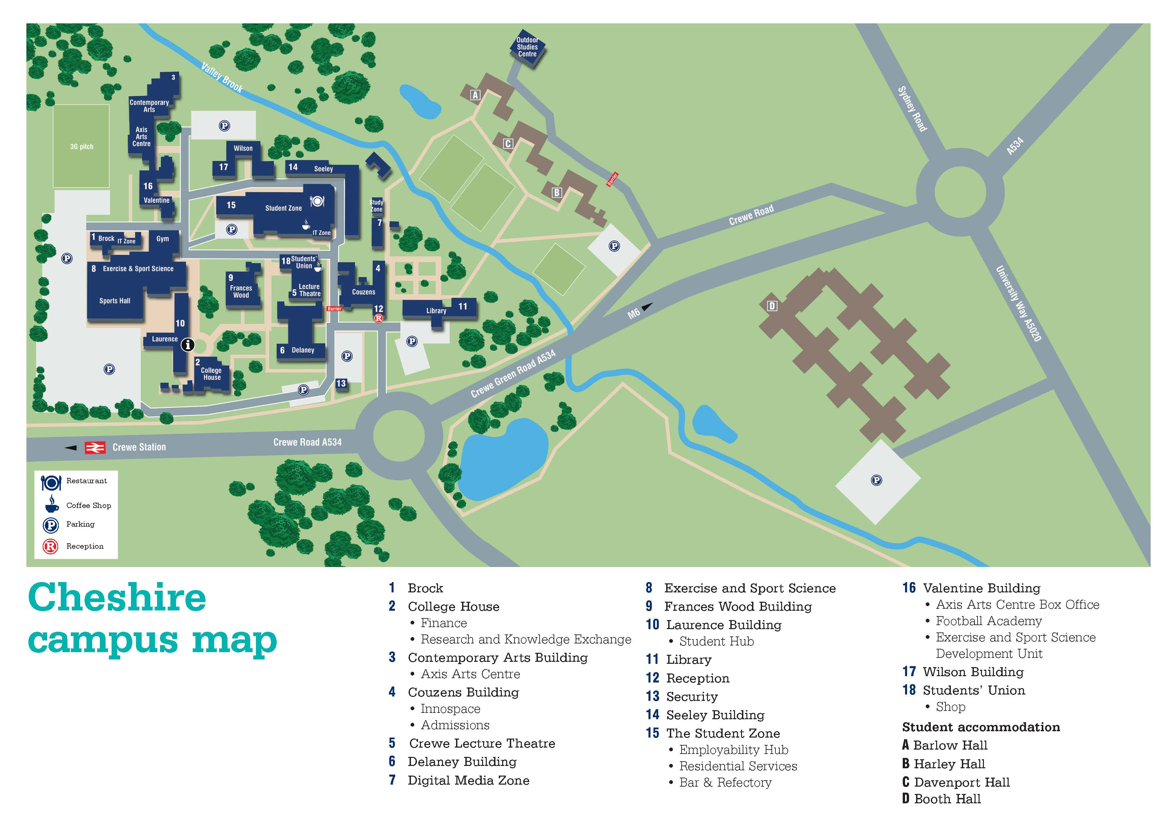

Local Amenities

Post Office
Address: Crewe Post Office, Unit 3, Victoria Centre, Crewe CW1 2PU (1.3 miles / 28 minutes’ walk)

Supermarket
Tesco Esso Express
Address: Tesco Esso Express, Tommy's Ln, Crewe CW1 6DN (0.4 miles / 6 minutes’ walk)

ATM
Tesco Esso Express
Address: Tesco Esso Express, Tommy's Ln, Crewe CW1 6DN (0.4 miles / 6 minutes’ walk)

Chemist
Well Pharmacy,
Address: 139-141 Nantwich Rd, Crewe CW2 6DF (0.9 miles / 21 minutes’ walk)

Hospital
Leighton Hospital
Address: Middlewich Rd, Crewe CW1 4QJ (3.6 miles / 13 minutes’ drive)

Doctors
Gresty Brook Medical Centre
Address: Brookhouse Dr, Crewe CW2 6NA (1.5 miles / 28 minutes’ walk / 7 minutes’ drive)
*N.B. If a student is ill and requires a doctor, then a group leader and a UKLC staff member will take the student to the NHS medical centre. The student will be required to fill out a temporary patient form and will be seen on the same day.*

Dentist
Alchemy Dental Practice
Address: 203 Edleston Rd, Crewe CW2 7HT (1.2 miles / 20 minutes’ walk / 4 minutes’ drive)

Bus Stops
Located at the end of Nantwich Road, about a 15 minute walk. There are frequent buses that run into the centre and surrounding towns.

Train Stations
Crewe Train Station
Address: Nantwich Rd, Crewe CW2 6HR (0.5 miles / 11 minutes’ walk)
Frequent trains to London and Chester

Taxi Companies
Take me Crewe - 01270 211222
A Star Taxis - 01270 895044

Coffee Shops
Starbucks Coffee,
Seattle-based coffeehouse chain known for its signature roasts, light bites and WiFi availability.
Address: 18 Weston Rd, Crewe CW1 6FX (0.5 miles / 12 minutes’ walk)

Rhode Island Coffee
Order a cup of our unique blend, lovingly crafted coffee, team it with a good helping of our savoury and sweet treats, find a seat, kick off your shoes and make yourself at home. You can bring a good book (or find one on our bookshelf), read a newspaper, or just sit back and relax – think of the early morning mists swirling around the sands of Narragansett Bay, at the heart of Rhode Island.
Address: 17 Victoria St, Crewe CW1 1HF (1.4 miles / 20 minutes’ walk)

Restaurants
The Cheshire Inn
Stylish pub serving classic international favourites, grill dishes and burgers.
Address: 37 Nantwich Rd, Crewe CW2 6AF (0.7 miles / 22 minutes’ walk)

Gio’s
Classic Italian Restaurant, plus some modern takes on pizza and pasta in tall-windowed restaurant with brick-arches.
Address: 23/25 Nantwich Rd, Crewe CW2 6AF (0.7 miles / 22 minutes’ walk)
Hickory's - Gresty Green
Hickory’s Smokehouse is a family-friendly restaurant & bar born from a road trip across America’s Southern States. They learnt all things smokin’ from the best pitmasters across the region and created a menu bursting with smokehouse classics and barbecue favourites.
Address: 332 Crewe Rd, Shavington, Crewe CW2 5AF (1.7 miles / 8 minutes’ drive)

Accommodation

The accommodation is located approximately 300 meters from the main campus. There are 200 beds at Booth Hall with flats that contain between 1-7 single en-suite bedrooms. Each corridor has a kitchen on every floor that can be accessed by students and group leaders.

Room Allocation
We divide the students up according to their age, gender and group where possible. We take into consideration any specific requests, i.e. friends who want to be close to each other. Group Leaders will stay in the same house as their students. Room allocation is normally done on arrival. If you would like any further information on this, please contact us.

Housekeeping
Bedding is changed once a week. Towels will not be provided at this centre. Bedrooms are deep cleaned once a week Monday – Friday. There is laundry available in Booth Hall, which is app/card operated. An approximate cost of a wash and dry is £6.30.

Key Loss
If any access card is lost during the stay, there will be a £10 replacement fee. If a key is lost during the stay, there will be a £50 fee for a replacement.

Deposits
We will ask each student for a deposit of €25/£25 on arrival. We will check their rooms before they arrive and before they leave and return the money if everything is in order. If there is damage to the houses and nobody admits fault, we will ask everyone in the house to share the cost.

Meals

When the students are on campus, they will eat their meals in the dining hall on site. When they are out on full day excursions, they will be provided with packed lunches.
Cooked breakfast is supplied at the weekends.

Meal times
Breakfast: 08:00 – 08:45
Lunch: 12:30 - 13:30
Dinner: 18:00 - 19:00

If we are aware in advance, we can advise the catering staff of any dietary requirements or allergies and the canteen staff can cater to these.
*Mealtimes are subject to change
 | Monday | Tuesday | Wednesday | Thursday | Friday | Saturday | Sunday
Breakfast | Selection of pastries, cold meats,  Toast, Cereal,  Yoghurt  Butter, Spreads, fruit, juices and tea/coffee | Selection of pastries, cold meats,  Toast, Cereal,  Yoghurt  Butter, Spreads, fruit, juices and tea/coffee | Selection of pastries, cold meats,  Toast, Cereal,  Yoghurt  Butter, Spreads, fruit, juices and tea/coffee | Selection of pastries, cold meats,  Toast, Cereal,  Yoghurt  Butter, Spreads, fruit, juices and tea/coffee , | Selection of pastries, cold meats,  Toast, Cereal,  Yoghurt  Butter, Spreads, fruit, juices and tea/coffee | Cooked breakfast – Bacon, Sausage, Eggs, beans, mushrooms, hash browns. Toast, cereals, fruit, juices and tea/coffee | Cooked breakfast – Bacon, Sausage, Eggs, beans, mushrooms, hash browns. Toast, cereals, fruit, juices and tea/coffee
Lunch | Selection of wraps  Chicken Nuggets  Vegetable Curry  Garlic and Herb Potatoes | Southern Fried Chicken burgers  Veggie burgers  Chips  Selection of mixed salads | Hot dogs  Quorn hot dogs  Wedges  Onion Rings  Selection of toppings | Selection of wraps  Chicken wings  Selection of mixed salads  Potatoes | Battered fish goujons  Cauliflower and Bean Steak  Chips  Peas | Beef burgers  BBQ chicken burger  Spicy bean burger  Wedges  Selection of mixed salads | Thai green curry  Vegetable Katsu curry  Rice  Naan Breads
Dinner | Chilli con carne tacos  Cheese and Salad tacos  Selection of mixed salads  Breads  Fruit Salad | Chicken Tikka Masala  Onion Bhajis and Samosas  Rice and breads  Chocolate brownie with cream | Chicken Arrabiata pasta  Creamy bacon and mushroom pasta  Selection of vegetables  Garlic bread  Vanilla Cheesecake | Beef Lasagne  Vegetable Lasagne  Roasted broccoli  Cheesy Garlic Bread  Apple turnover, fruit and jelly pots. | Chicken Fajitas  Vegetable Fajitas  Potato wedges  Tortilla chips and salsa  Chocolate chip cookies | Beef and Mushroom pie  Butternut squash pie  Mash potato  Seasonal vegetables  Ice cream | Roast chicken dinner  Roast Quorn dinner  Seasonal vegetables  Roast potatoes and Gravy  Sticky toffee pudding
Cheshire Campus - Sample Menu

Technology

Wi-fi is available in all main areas and in the accommodation. All campus wi-fi is password protected. We normally only give this password out to group leaders / adults. Being a college, the internet access is firewalled as per the college regulations. It is at the Group Leader’s discretion whether they give these details to their students. There is computer access on campus and you will have access to this on a timetabled basis. There are no public phones on site. The nearest are in Crewe town center.

Security

There is CCTV coverage on campus and 24/7 duty security/wardens. The main gate is locked at midnight.

Emergency contacts: Each student will be given a wristband when they arrive, and this will have the following emergency telephone number printed on it: 00 44 1244 567695. If you need to contact the centre in the event of an emergency please call this number and follow the options for the relevant centre, this will then put you through to the person on duty.

Certain basic guidelines are common to all centres and students. Students should:
- Never walk away alone!
- Never leave the residence without permission in the evening!
- Always make sure they have understood when and where the meeting point is whilst
out on excursions!
- Always wear their identification lanyard and their UKLC wristband! *
*students found not wearing their lanyard or wristband will be fined £1

Safety

- Remember that there is a 24-hour emergency telephone number on the wristband (0044 1244 567695) and that the number for the emergency services (Ambulance/Police/Fire) in England is 999, or the single emergency number for the EU including the UK is 112 or you can call 101 to report a crime where you do not need an emergency response
- The police are there to help and protect and can be asked for assistance!
- Never respond to someone if you feel threatened, simply walk away!
- Always give your money to the UKLC management team to put in the safe and never to carry large amounts of cash around!
- Be careful crossing the road. Remember that in the UK we drive on the left!
- If you are ill or need a doctor, tell a member of UKLC staff immediately!

Insurance and valuables
Although all houses will be accessed via swipe cards, it is suggested that students try to avoid bringing very expensive items with them. If they are bringing valuables with them, it essential that they have sufficient insurance to cover any loss of damage as neither the centre nor the company can be held responsible if anything goes missing. The Centre Manager will have access to a safe if it is required.

Teaching

We know how important it is for each individual student to find their own path in language learning. We use a wide range of methods to engage and stimulate our students. This is why we have created a curriculum based on the students’ age, level and needs, structured into four different programmes:
FUN (ages 8-10)
Engaging lessons that offer a wide range of materials and activities specific for our young learners, making games into lessons and lessons into games. Available in levels A1-B1.

CONNECTION (ages 10-13)
Dynamic lessons covering a variety of topics and media, designed to engage students using tools native to the fast-paced world they are growing up in. Available in levels A1-C1.

ACTION (ages 13-16)
Lessons tailored for learners stepping into their teenage years. This programme focuses on activating students’ knowledge and competencies to balance developing a personal voice while contributing effectively to a team. Available in levels A1-C1.

PURPOSE (ages 16-18)

Lessons tailored for our students approaching adulthood, designed to kickstart their lives not only as maturing youths but also as forward-thinking global citizens. Available in levels A1-C2.

The Connection, Action, and Purpose programmes consist of three different lessons a day:

FOCUS ON LANGUAGE

These lessons aim to empower our students’ linguistic awareness and capabilities by working on all language skills (reading, writing, listening, speaking) and systems (grammar, phonology, lexis, discourse), as well as using materials relevant to exam preparation (KET, PET, FCE, CAE, TOEFL, IELTS, GESE).

FOCUS ON LEADERSHIP

This programme is designed to equip students with essential 21st-century skills, focusing on leadership development, communication and teamwork. Students build the confidence and competencies needed to grow into empowered young adults.

FOCUS ON CULTURE
These lessons combine CLIL and British culture, allowing students to use English to explore a range of disciplines, including art, literature, natural sciences, as well as the history and geography of the UK.

Placement tests
We offer classes at four levels, from elementary to advanced. Students take a placement test on their first day of classes to ensure they are placed at the correct level.

Once the tests have been marked, students won’t be told their score unless they specifically ask for it but will be placed into a class based on these results.

If students are not happy with their level, they can speak with the Course Director who will decide if it is necessary for the student to change levels.

We always try to split groups into different classes to mix nationalities, but this does depend on their levels and the numbers of students that we have on site.

We will provide all course materials including a journal and a pen.

Students are taught in class sizes up to 16.

Programme

All UKLC summer programmes include:

- 15 hours of English lessons
- Full board accommodation in residence
- Full programme of excursions, activities and evening entertainment
- 1 free leader for 15 students
- Placement test on arrival and End of Course Certificate

These are summaries of UKLC English Plus programmes** for Summer 2026 at Clifton College, Bristol:

English Plus Multi-Activity
The “typical” summer programme consisting of a wide variety of activities and sports. Sessions are structured and are coached by specialist staff. Sessions can include tennis, basketball, volleyball, swimming, photography workshops, dance, football, and drama etc. Students are moved through two or three activities on rotation in each session.

English Plus Performing Arts*
During these sessions, students passionate about dancing, acting, or singing will immerse themselves in hands-on training designed to unleash their creative potential on any kind of stage. They will not only develop their talents but also experience the thrill of live performance, collaboration, and artistic expression.

English Plus Intensive English & Community Building*
Additional English lessons for those who really want to maximise their language learning during their stay in the UK. Based on UKLC's integral community-building approach, these additional lessons aim to help students develop an active role in the school as a thriving community, with its challenges, complexities and opportunity for collective growth. The Community Building lessons focus on how to empower students to work together to find possible solutions to these needs and issues by communicating with people on campus. Students create these projects that they are responsible for in order to improve these issues on campus.

*Students aged between 11 and 17 who are enrolled on Multi-Activity or English Plus courses will be divided by age for activities where numbers allow. Students can choose whether to enrol on the Multi-Activity or an English Plus course.
All students aged between 8 and 10 will be automatically enrolled on the multi activity programme.

**These programmes vary at each centre. A minimum of 10 students applies to each programme and each student will be asked to select a 1st and 2nd option before arrival which they will join for the duration for their stay. Students who do not choose in advance will join the standard English Plus Multi-Activity.

A typical day for students

08:00 – 09:00 Breakfast

09:00 – 10:00 Lesson 1

10:00 – 10:15 Break

10:15 – 11:15 Lesson 2

11:15 – 11:30 Break

11:30 – 12:30 Lesson 3

12:30 – 13:30 Lunch

14:00 – 17:30 Afternoon Activities

18:30 – 19:30 Dinner

20:00 – 22:00 Evening Activities

22:00 Bedtime

Cheshire Campus, Crewe – Sample Programme 2026

 |  | Morning |  | Afternoon | Evening
Week 1 | Monday | English Testing / Lessons |  | Multi-Activity or Chosen Programme | Speed Dating
 | Tuesday | Lessons |  | Crewe Orientation and Scavenger Hunt | Paparazzi or Conversation Club
 | Wednesday | Lessons | Vlogging Workshop or Chosen Programme |  | Quiz Night
 | Thursday | Lessons |  | Chester with Roman Tour | Mini-Olympics or  Conversation Club
 | Friday | Lessons | Multi-Activity or Chosen Programme |  | Attractions
 | Saturday | Manchester with Manchester City Etihad Stadium Tour |  |  | Oscars
 | Sunday | Optional Excursion, Free Time or Activities |  |  | Film Night
Week 2 | Monday | Lessons |  | Multi-Activity or Chosen Programme | Trashion Show
 | Tuesday | Lessons |  | Crewe town orientation | Red Vs Blue or Conversation Club
 | Wednesday | Lessons | Vlogging Workshop or Chosen Programme |  | Around the World
 | Thursday | Lessons |  | Liverpool with Museum of Liverpool | Karaoke or  Conversation Club
 | Friday | Lessons | Multi-Activity or Chosen Programme |  | Disco
 | Saturday | Birmingham with Think-tank Museum |  |  | Talent Show
 | Sunday | Depart

Evening entertainment

The UK Language Courses staff plan fantastic activities to make sure the students enjoy their evenings. For example: discos, quizzes, fashion shows, blind date, sports tournaments etc. We ask Group Leaders to encourage students to participate as much as possible and to communicate any special ideas or requests from students.

Here are a few brief descriptions of just some of our activities for students to join in on:

Around the World
Consists of a number of different stations based on activities from different countries. One staff member will be placed at each activity station. They will each represent a country and have to create an activity related to that country (for example: New Zealand – The Haka). Students will be divided into groups and given a time for each station. Students will visit each station.

Oscars Night
Involves students watching a number of scenes from selected films. They will have the chance to re-enact a famous selected scene. Creating their own script, which must be in English and costumes (out of various given equipment). Scenes will be shown on a big screen for everyone to watch. Awards will be given by UKLC staff for the best reproduction.

Speed Dating
Enables students from mixed nationalities to socialise and get to know each other whilst improving their spoken English. Students will have a short period of time to have a conversation on their interests, hobbies etc. Once the given time finishes they will move to another student and begin the same process again.

Talent Show
Gives students the opportunity to perform talents such as singing, dancing and acting in front of the whole centre! Sign-up sheets will be available in the centre a few days before the event. There will be judges who will score the performances and give positive feedback to each student who performs on the evening.







We look forward to welcoming you to Cheshire Campus, Crewe in 2026!

